Responsibility: Trading Community manager
- Navigation: Trading Community →Administration → Classifications
Search Page opens by default. Click on “Create Class Category”

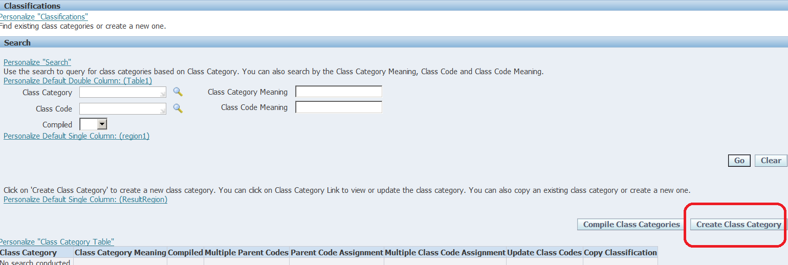

- Populate the class category name, meaning, description.

Ensure “Assign entities” is populated with proper value (leave default as is) and clock on “select” check box.
Select “Allow Multiple Class Assignments”
Click “Apply and Create Class Codes”.

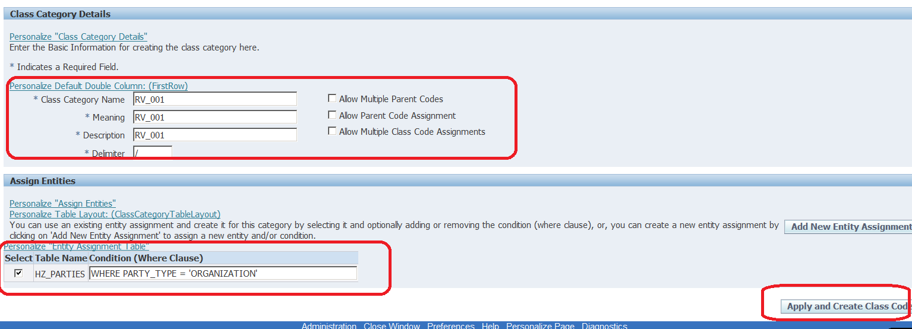

- Now create your codes that you need as shown below and click “Apply”

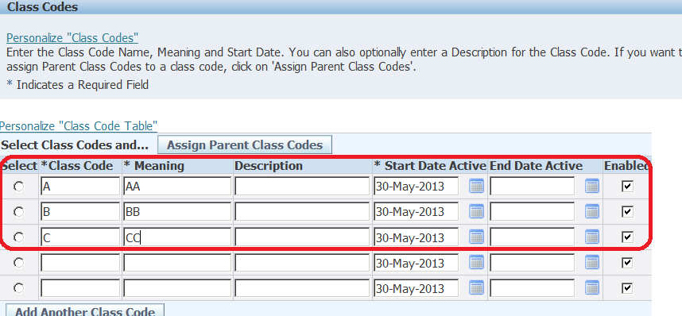

- Now ensure that new category is compiled.

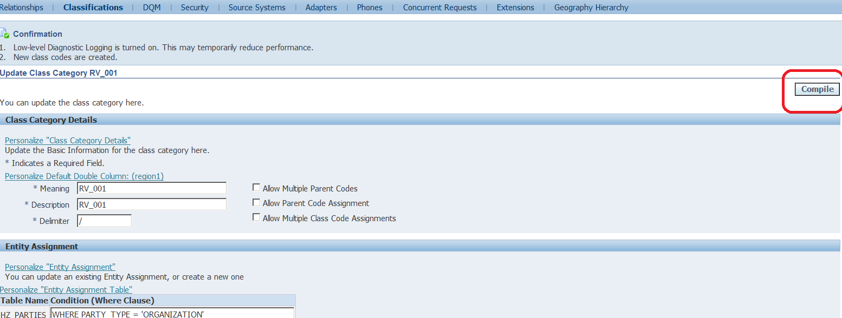
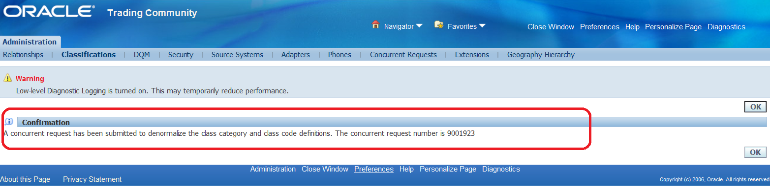
- Once the compilation is complete, you will able to query codes under receivables lookup.
To ensure that compilation is successful, requery the new created class and ensure that compiled =Yes
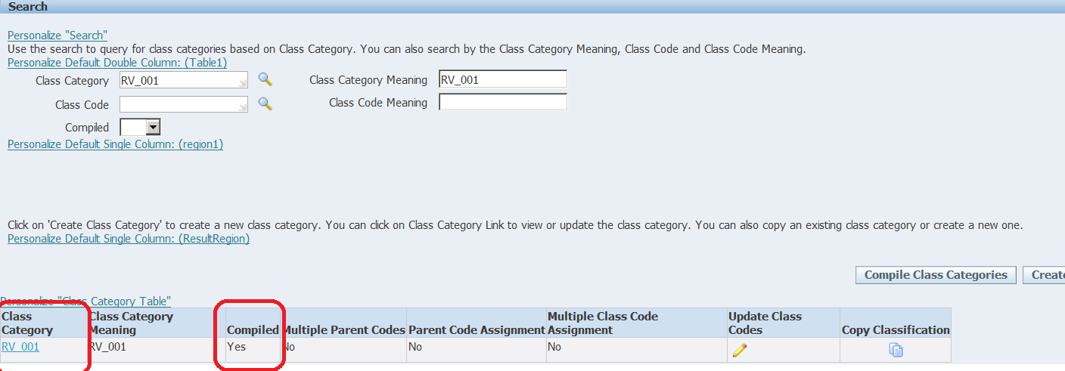

- AR Superuser -> Setup -> System -> Quickcode -> Receivables
Search “HZ_CREATED_BY_MODULES”
Add “USER_ENTERED”

- It is now no longer possible to update the lookup codes for industry classification but you can use the public pl/sql api to set class category into industrial group.

Please see attached file Industrial_Class_API.txt for source code.
Modify the sample code by replacing TEST_CLASS with your class category
-- put your class_category here
l_class := 'TEST_CLASS'; --for example here, make TEST_CLASS into industrial group
--1,先在快码HZ_CREATED_BY_MODULES中增加一个USER_ENTERED
--2,将CUSTOMER_BUSINESS_TYPE注入于行业分类
DECLARE
p_init_msg_list VARCHAR2(32767);
p_code_assignment_rec APPS.HZ_CLASSIFICATION_V2PUB.CODE_ASSIGNMENT_REC_TYPE;
x_return_status VARCHAR2(32767);
x_msg_count NUMBER;
x_msg_data VARCHAR2(32767);
x_code_assignment_id NUMBER;
l_class varchar(30);

BEGIN

fnd_global.apps_initialize('0','53463','222');

-- put your class_category here
l_class := 'CUSTOMER_BUSINESS_TYPE'; --for example here, make TEST_CLASS into industrial group

p_init_msg_list := NULL;
p_code_assignment_rec.CODE_ASSIGNMENT_ID := NULL;
p_code_assignment_rec.OWNER_TABLE_NAME := 'HZ_CLASS_CATEGORIES';
p_code_assignment_rec.OWNER_TABLE_ID := NULL;
p_code_assignment_rec.OWNER_TABLE_KEY_1 := l_class;
p_code_assignment_rec.OWNER_TABLE_KEY_2 := NULL;
p_code_assignment_rec.OWNER_TABLE_KEY_3 := NULL;
p_code_assignment_rec.OWNER_TABLE_KEY_4 := NULL;
p_code_assignment_rec.OWNER_TABLE_KEY_5 := NULL;
p_code_assignment_rec.CLASS_CATEGORY := 'CLASS_CATEGORY_GROUP';
p_code_assignment_rec.CLASS_CODE := 'INDUSTRIAL_GROUP';
p_code_assignment_rec.PRIMARY_FLAG := 'N';
p_code_assignment_rec.CONTENT_SOURCE_TYPE := 'USER_ENTERED';
p_code_assignment_rec.START_DATE_ACTIVE := trunc(sysdate);
p_code_assignment_rec.END_DATE_ACTIVE := NULL;
p_code_assignment_rec.STATUS := NULL;
p_code_assignment_rec.CREATED_BY_MODULE := 'USER_ENTERED';
p_code_assignment_rec.RANK := NULL;
p_code_assignment_rec.APPLICATION_ID := NULL;
p_code_assignment_rec.ACTUAL_CONTENT_SOURCE := 'USER_ENTERED';

-- Now call the stored program

-- Note: You have to use SQL Editor to edit and run this program. Therefore you cannot use bind variables to pass arguments.

hz_classification_v2pub.create_code_assignment(p_init_msg_list,p_code_assignment_rec,x_return_status,x_msg_count,x_msg_data,x_code_assignment_id);
commit;
-- Output the results
dbms_output.put_line(SubStr('x_return_status = '||x_return_status,1,255));
dbms_output.put_line(SubStr('x_code_assignment_id = '||TO_CHAR(x_code_assignment_id), 1, 255));
dbms_output.put_line(SubStr('x_msg_count = '||TO_CHAR(x_msg_count), 1, 255));
dbms_output.put_line(SubStr('x_msg_data = '||x_msg_data,1,255));

IF x_msg_count > 1 THEN
if x_msg_count > 10 then x_msg_count :=10; end if;
FOR i IN 1..x_msg_count LOOP
dbms_output.put_line(' Debug '||SubStr(FND_MSG_PUB.Get( p_encoded => FND_API.G_FALSE ),1,255));
END LOOP;
END IF;

EXCEPTION
WHEN OTHERS THEN
dbms_output.put_line(SubStr('Error '||TO_CHAR(SQLCODE)||': '||SQLERRM, 1, 255));
RAISE;
END;
/

- Once the PL/SQL block is run successfully, execute the following SQL to ensure that new class has been added as LOV for industrial classification.

Run the query below to check if your class category is showing up in the results:
select OWNER_TABLE_KEY_1 from hz_code_assignments
where OWNER_TABLE_NAME = 'HZ_CLASS_CATEGORIES'
and CLASS_CATEGORY = 'CLASS_CATEGORY_GROUP'
and class_code = 'INDUSTRIAL_GROUP';

- Now you will be able to see the added category class in LOV
